**Project Platform**

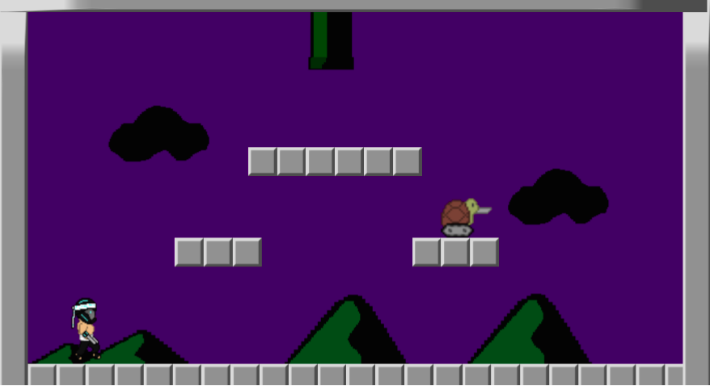

User Manual

Table of Contents

Introduction…………………………………………...……… 2

How to Play…………………………………………………... 3 - 4

Keyboard Commands

Objectives

Introduction

*Project Platform* is a game that can be played only on desktop computers. It is quite similar to the famous game called *Super Mario*, which is one of the most famous games and has had a huge number of players.

*Project Platform* is free and available for everyone. It can be played by people of any age and you don’t need to have much experience in gaming. Even if you’re a dilettante and have just got into the world of gaming, this manual will guide you through the game and the process of playing it, which is relatively simple.

The game is more of a combat game and it consists of three main worlds. Each of these three worlds has three levels. There is a main character, whose appearance is more like a fighter or sort of a ninja. There are also enemies, who have different looks in different worlds and levels of the game. The worlds and levels themselves also differ in terms of the appearance. Some have different backgrounds, different enemies and different structure of obstacles.

Each level has a certain degree of difficulty and that starts increasing when reaching a higher level than the current one. The levels also have music in the background. The music is more of an action music, which plays throughout the level and its sound increases when the player faces enemies or tough situations during the game. Its main function is to keep the player focused on the game and give him or her a kind of a real-life effect.

How to Play

The game normally starts in the first level of the first world. The primary and the only game input is a computer keyboard. The user can control the main character by using the keyboard arrows on the bottom right and by using the space button or key which is in the bottom center of the keyboard. Note, however, that using the down or up arrow will not affect the player during the game. The buttons’ symbols and their functionalities are shown below:

**→** Moves the player to the right.

**←** Moves the player to the left.

SPACE Makes the player jump. If pressed continuously more than once, it will allow the player to jump much higher than the normal height.

Another possibility for controlling the player through the keyboard is by using the WASD buttons on the left. Particularly, A has the same function as the left arrow and D has the same function as the right arrow.

Main Character :



The objectives of the game are quite simple. The user has to move the main character up to the end of the level. If that happens, the character moves or transits to the next level. Throughout each level, there is a number of obstacles, which the player has to pass in order to complete the level. There is also a certain number of enemies that may be moving around the screen or staying still somewhere in the level or near an obstacle. The user has to move the player so that it does not come into contact with the enemies around it. If the player is touched by any of the enemies, then the player dies and the game ends and the user has to start over. Different images of the enemies are shown below:

   

In addition to these elements, each level of the game will also have a timer. The timer will be shown on the screen while the user is playing. It will show the time left for which the user can continue playing the game. If that time goes to zero, then the game automatically ends and the user has to start over.

Throughout the game, the user will also have the chance to collect different items, which will simply be part of his/her collection, which the system will keep track of until the game is over. These items will be shown in various locations throughout each level depending on the difficulty of that level.

At the end of each level, there will be a transition to the next level of that current world or to a new world depending on the present level. If the user manages to get the player to the end of last level of the last world alive passing all the obstacles and enemies, then he has finished the game successfully.

System Manual

**System Name**: Start Menu

**System Type**: Screen

**Purpose**: This screen is used to allow the user to begin playing the game as they choose

**Description and Use**: The screen consists of words prompting the user to perform a certain action in order to continue into the game. Upon preforming the demanded action, the action is the form of the pressing of a specific button; the screen will go away bringing forth the start of the game action.

**System Name**: Game Levels

**System Type**: File

**Purpose**: The game levels provide a physical atmosphere for the game to be played on

**Description and Use**: The level files are files built into the game. They consist of all of the background and foreground, non-character visual aspects of the game. They allow the user to navigate through the game via paths, platforms, and other navigable devices. The levels also include the scenery that makes up all of the background and untouchable aspects that are seen in the game. The levels are built in and do not require any user action to load. Upon completing objectives the user will automatically be transferred to the next level.

**System Name**: Level Switching

**System Type**: Code

**Purpose**: This system allows for the automatic switching between different levels.

**Description and Use**: The level switching system is used to manage the transportation of the main character into different areas of the game. The user simply needs to complete the level objectives in order for this system to begin working. Often times the level objective is simply for the user to make it to the end of the level. Upon doing this the code kicks in and transports the user to the following level

**System Name**: Main Character

**System Type**: File

**Purpose**: This is used in order to have a visual representation of the Main Character of the game.

**Description and Use**: The Main Character is the protagonist of the game. It is the object that is controlled by the user in order to complete the game objectives

**System Name**: Main Character Movement

**System Type**: Code

**Purpose**: This screen is used to allow the user to move the Main Character

**Description and Use**: The Main Character Movement is the script if code that allows the user to control the main character. The script is preloaded when the game begins. In order to use this script the user must simply press the correct buttons to accomplish the type of movement they are intending for the character to perform.

**System Name**: Enemy Characters

**System Type**: File

**Purpose**: This makes up the non-playable characters of the games that seek to increase difficulty.

**Description and Use**: The enemy characters are found all across the game and are automatically put into place on the loading of the level. The enemy characters are dangerous to the main character and must be avoided in order to successfully complete a level of the game.

**System Name**: Enemy AI

**System Type**: Code

**Purpose**: This is the code that allows the enemies to move around the levels and tells how they interact with the main character

**Description and Use**: The enemy AI is in charge of handling enemy movement as well as making the enemies dangerous to the main character. It contains simply movement controls and is set up so that on contact with an enemy, the main character will die.

**System Name**: Music

**System Type**: Audio

**Purpose**: This consists of the audio that is heard throughout the game.

**Description and Use**: The music in the game is used to enhance the user’s experience. It is heard on all of the levels and changes based on what level the user is on. The music for each level is specific in theme to the level itself.

**System Name**: Time/Score

**System Type**: Data

**Purpose**: This is the data that is used to keep track of the user’s level time and score

**Description and Use**: The timer keeps track of long the user has been playing on a specific level. It increases by one for each second that passes. The score is sued to keep track of some of the optional game objectives. It increases as the main character comes in contact with gems, as well as other various positive things that the user is able to accomplish.

**System Name**: Ending screen

**System Type**: Screen

**Purpose**: This screen is used to inform the user that they have completed the game

**Description and Use**: This screen comes up on completion of the final level of the game. It informs the user that they have won the game. At this point there is nothing more to play in the game and the user can choose to play the game again or exit the application.